C0542 - Change Sales and CRM Basic Data

|  |  |  |  |  |
| --- | --- | --- | --- | --- |
| **Ver** | **Date** | **Author** | **Comments** | **Reviewed by** |
| 1 | 01/03/2020 | Tom Bell | CRIM 0542 - CRM | TBC |
|  |  |  |  |  |

Requirements 2

Prerequisites 2

Solution Overview 2

Solution Details 2

Security 3

Companies 3

Data Migration 3

Test Steps 3

Technical Implementation 3

Requirements

Change the Sales and CRM basic data settings “Close Business Opportunity when Create Customer Order” default value to TRUE.

Prerequisites

<Describe any pre-requisites that this development may rely upon, data configuration or other developments>

Solution Overview

The below screenshot shows the “Close Business Opportunity when Create Customer Order” default line. Highlighted in yellow is the field that must be changed to TRUE like the screenshot below.

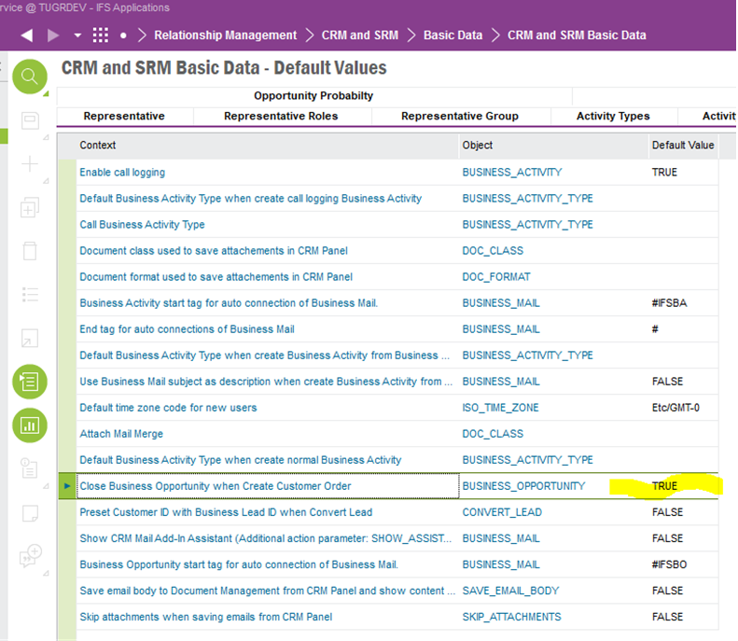

Solution Details

N/A

**Technical.**

Field Definitions.

<New Field/CLU Definition>

|  |  |  |  |  |  |  |
| --- | --- | --- | --- | --- | --- | --- |
| New DB Object Name | DB Object Item/Field Names | Item Description | Item Data Type | Item Syntax | Calculation Spec, if Derived | LOVs/Enums/Is Mandatory? |
|  |  |  |  |  |  |  |
|  |  |  |  |  |  |  |
|  |  |  |  |  |  |  |
|  |  |  |  |  |  |  |
|  |  |  |  |  |  |  |
|  |  |  |  |  |  |  |
|  |  |  |  |  |  |  |
|  |  |  |  |  |  |  |
|  |  |  |  |  |  |  |
|  |  |  |  |  |  |  |
|  |  |  |  |  |  |  |
|  |  |  |  |  |  |  |

Security

<Define security controls> (Who needs access to this and will it be restricted from any other users etc)

Companies

Applies to the following companies. All.

|  |  |
| --- | --- |
| **Company** | **Required (Y/N)** |
| 1201 | Y |
| TBC |  |
|  |  |

Data Migration

<Describe any data migration impacts this development may have – i.e additional data to be migrated>

Test Steps

<Steps that needs to be taken to test this change. Please provide expected results> Updated post solution.

|  |  |  |
| --- | --- | --- |
| **No** | **Script\Test Steps** | **Expected Result** |
|  |  |  |
|  |  |  |

Technical Implementation

<Completed by the technical developer - Technical solution, list packages, functions, Custom menus created etc >

**Package**

N/A

**Permission Granted –** IFS_ALL

Set the following as TRUE manually as this is a basic data setup.